
The DESTIN Toolkit
WP3 Training for Trainers
Dec 2019 (WP3 TFT TOOLKIT 2.1)

This toolkit has been assembled as part of the DESTIN KA2 project.
This project has been co-funded with support from the European Commission. This information reflects the views only of the authors, and the Commission cannot be held responsible for any use which may be made of the information contained therein.
How to use this DESTIN Training for Trainers Toolkit
The original DESTIN toolkit is quite large – this ‘Training for Trainers toolkit’ is more focused. This toolkit is designed to give your DESTIN university programme teams tools they will use as part of their in-house trainings as they start the revision and rewriting of their journalism study programmes.
This Training for Trainers toolkit will be delivered in two ways… as a pdf file, with core toolkit information and then links to relevant web accessible content (including to the main DESTIN toolkit).
The toolkit concept remains to address the core Programme Design and Teaching and Learning issues which DESTIN universities have identified in the Bath (Feb 2019) and Kyiv (May 2019) conferences. Additional issues may arise as you start your programme redesign work. If you let me know about these, we will address them by providing you with additional resources, exercises and links to web-accessible content.
We worked through this toolkit in the December 2019 DESTIN WP3 Training for Trainers in Kyiv.
This toolkit includes core exercises, guidelines, checklists about subjects including…
How to use this DESTIN Training for Trainers Toolkit | Page 01
The DESTIN one-page Module Descriptor Template | Page 3
The DESTIN one-page Module Descriptor Template with notes and guidance in RED ink! | Page 5
The Study Programme Design or Revision Process | Page 07
Next Steps for DESTIN CDTs (Course Development Teams) | Page 08
Blank IADT Module Descriptor template (with explanatory text in red italics) | Page 09
The Study Programme Design or Revision Process (making many small modules into one larger module) | Page 21
Learning Outcomes ONE – WHAT are Learning Outcomes?  (from original DESTIN toolkit) | Page 23
Learning Outcomes TWO – A TCD Checklist  (from original DESTIN toolkit) | Page 28
Programme Learning Outcomes | Page 31
Table Mapping a Programme against a National Framework of Qualifications | Page 33
The Assessment of Students – BSU’s Paul Hyland and Inna Pomerina (2015) | Page 39
Programme Design – sample charts, tables and matrices | Page 45
Terminology (DESTIN and SSU/IADT KA1 ICM) | Page 47
The Module Descriptor as presented by IADT’s Rónán O Muirthile on 13th May 2019 in Kyiv | Page 57
MAY 2019 DESTIN WP3 European Curriculum Design TOOLKIT  Toolkit Overview – Index | Page 69
end | Page 71

The DESTIN one-page Module Descriptor Template
This DESTIN ‘Training for Trainers toolkit’ one-page module descriptor template is for guidance purposes only. Feel free to use it if you wish, but make sure that you’re complying with your own university’s Methodological Office templates, standards and procedures in the preparation of your programme documents.
Your faculty or university:
Study Programme:
Stage |  | Module/course |  | Module Title
Credits |  | Year |  | Weeks

Commence |  | Briefing
Module Lead/s |  | Lecturers
 |  | VLs

Formative Assessments Please refer to detailed project schedule for key dates and deliverables.
Summative Assessments Please refer to detailed project schedule for key dates and deliverables.

Module Schedule

Project Aims
What You Will LEARN | What You Will DO

Learning Outcomes | Indicative Deliverables
Intended Learning Outcomes upon successful completion of Module

The DESTIN one-page Module Descriptor Template with notes and guidance in RED ink!
Svitlana Bezchotnikova of Mariupol State University suggested at the DECEMBER 2019 Kyiv traing for trainers that some notes would be useful in this one-page module descriptor template… Thanks Svitlana!
This DESTIN ‘Training for Trainers toolkit’ one-page module descriptor template is for guidance purposes only. Feel free to use it if you wish, but make sure that you’re complying with your own university’s Methodological Office templates, standards and procedures in the preparation of your programme documents.
Your faculty or university: The name of your University and your Faculty
Study Programme: The Full Name and Level of your Study Programme (eg Journailism (BA Hons))
Stage | The year of study (Stage 1) | Module/course | The Module or Course might be part of a bigger course ‘First Year Tech Skills’ | Module Title | The Module Name ‘Basic TV Interview Techniques’
Credits | ECTS credits | Year | The actual academic year of study | Weeks | How many weeks the students will be working on this module

Commence | The date the module will start – Monday 13th April 2019 | Briefing | The date, time and place the module briefing will be held – Monday 13th April 2019 14:00, Room A121
Module Lead/s | Which Professor (or Professors) are the MAIN lecturers on this module | Lecturers | The other Professors and Lecturers on the module
 |  | VLs | Any Visiting Lecturers teaching on the module

Formative Assessments Please refer to detailed project schedule for key dates and deliverables.
Are there any formative submission dates, tests or examinations? With formative assessment, the student will expect feedback which should help them to improve their learning, work and grade BEFORE the final summative assessment or examination.
Summative Assessments Please refer to detailed project schedule for key dates and deliverables.
When is the final (summative) submission date or examination?

Module Schedule
Perhaps some module schedule information here?

Project Aims
What You Will LEARN | What You Will DO
This is what the student can expect to LEARN through the module | These are the things the student can expect to be DOING in order to learn what she needs to learn through the module

Learning Outcomes | Indicative Deliverables
Intended Learning Outcomes upon successful completion of Module
The Learning Outcomes are the Minimum Intended Learning,,, | These are things which the student may be expected to DELIVER or SUBIT for assessment, to provide MEASURABLE EVIDENCE that she has achieved the module’s Minimum Learning Outcomes. ‘Indicative’ means that these are suggestions, possibilities. The deliverables can be changed by the professors or lecturers (as long as they tell their students well in advance of the assessment and as long as the students agree to and are prepared for those changes)…
On successful completion of this module, the learner will be able to…  - Create an illusion of life onscreen  - Present individual project process work and reflection  - Organise and plan her/his individual animation project work | A poster  A JPEG artefact  A 30 second vox-pop video interview  A web page

The Study Programme Design or Revision Process (from Paul Hyland, Kyiv, 14th May 2019)
A Simple Model of Programme Design…
- Consider the Context. You will all have to conform to the Ukrainian NFQ. You will all have to conform to your university regulations. Many programmes have to conform to professional standards or regulations (often these are set by national or international bodies). What is the EQF context? All of your universities will ultimately be pointed towards EU Higher Education?
- Try to do as much market research on the needs and requirements of students and stakeholders. Is there a gap in the market? What resources are available to you to run this new programme? Is there competition? Are there similar study programmes already in existence?
- I would strongly advise your programme team to look at the BEST equivalent study programmes in the world.
- Now set the Study Programme Aims. In Bath Spa University, we usually have 8 Programme Aims – but this may well be determined by your university and external regulations, graduate attributes, national, international and professional requirements. As Rónán said ‘start at the end’ – what will your graduates look like? According to my university regulations, I have 4 years for my study programme. What do I want my graduates to have learned in those 4 years? What ‘graduate attributes’ do I want to develop? How will my students’ learning be structured and progressed over the 4 years of the study programme? Be fair and honest about the Programme Aims. What do you want your students to do? Be a little bit distinctive if you can – different study programmes should have slightly different programme aims.
- How do my modules work? In sequence? All together? YOU must decide what is the best structure to allow your students to achieve the Programme Aims. Now, each of my programme team will be asked to write a module, or several modules. They must work together on this.
- The importance of Assessment to student learning. If I know what the assessments are, I should have a good idea of what the LOs, the Learning Outcomes are. If I know the LOs, I will know what teaching and learning is required. Personally, I like a module with 1 or 2 learning outcomes. 6 is too many! Learning outcomes can be anything observable. If it’s observable, it’s testable. There cannot be any secret knowledge.
- What students learn. How much they learn. How they learn. How effectively they learn. Most student learning takes place OUTSIDE of the classroom. If it’s not being assessed, students aren’t learning it? Getting any assessment system right is a complex task, a common problem for all tutors.
- For students, there must be no secret knowledge, no secret gardens. Assessment should be visible, transparent, participatory. The word assessment comes from the Latin ‘to sit down beside’. It’s a discussion. Where goals, standards and assessment criteria are unclear or unobserved by the teaching team, students will seek alternative explanations for the grades they receive.
- Feedback on my work has helped me to clarify things I did not understand.
- Questions to ask… How many assignments does your programme have? What kind of learning experiences do these assignments require and capture? How many assessments do you need to measure student achievement of a learning outcome? How many formative assignments does your programme have?
- Enabling students to become autonomous, self-directed learners differentiates Higher Education from secondary and vocational training. Our students do need to develop understanding of how to measure their learning. We need of course to be vigorous about our standards! We must continue to attend to the assessment of learning (as well as assessment for learning and assessment as learning).
Next Steps for DESTIN CDTs (Course Development Teams)
(from Paul Hyland, Kyiv, 17th May 2019)

Use this as a checklist as your study programme document develops. What has been done already? What still needs to be done?

- Get your dates (for your staff) into your calendar now, so your staff will know what needs to happen and by when. You all have Action Plans – you need to share these with your staff. Action Plans are for ALL of your team. Tick things off as you get them done. Keep things clear and doable!
- Plan for Training for Trainers in Kyiv. We know that you will need more support in making your changes. We will tell you about our plans for that.
- Toolkit: we will revise the toolkit (to create a specific Training for Trainers Toolkit). This will be based on the needs and requirements of the group (and on your suggestions from this week).
- Module Descriptors: Just develop one good module descriptor, one you can share with ALL your team members. It will serve as an example to all of your team. We will share Rónán’s descriptor with you (and an empty descriptor template as a .doc file).
- Programme Aims. These are fundamental. What will your graduates be able to do? What are their skills, competences and knowledge? As soon as your team can agree these, we will know exactly where we’re heading.
- Students should be involved in your programme revision and development. Ask them about what opportunities they want. What kind of programme do they want? What kind of students do they want to study with (maybe new and diverse cohorts of students)? Ask them! Gather evidence! Not only surveys! Focus groups! Discussion groups!
- QA: We need to get your revised programmes prepared in order to launch them by September 2020. Contact/Befriend your local QA office NOW! Get them on board! We might ask the Ministry for help on this.
- Documentation: We’ve set maximums. If you can do it with more concision, do that! Be precise! If you’re not clear, ask! We know this is a big request, just do it! Set deadlines for drafts! For example – when do you want all of your staff to have completed their new module descriptors? You’re a team! Work together!
- Peer Review Process: Understanding this process. You’ll need to have some meetings – tell people what will be involved. Explain the Quality Indicators – design your programme, the quality of your content.
- Students: For Your Information – you may have a legal obligation (you certainly have an educational obligation) to tell new students what they will be studying/how they will be studying, if you’ve made changes to your study programme.

Blank IADT Module Descriptor template (with explanatory text in red italics)

This is Based on Rónán O Muirthile’s REAL IADT ‘Certificate in Research Methods for the Creative Practices’ Module Descriptor – as presented by IADT’s Rónán O Muirthile on 13th May 2019 in Kyiv (see page of TfT toolkit)

Course Title DL129 – this is the institutional system code for the Study Programme

Certificate in Research Methods for the Creative Practices - the official NAME or TITLE of the Study Programme. In this case, the inclusion of ‘certificate’ in the name also means that the module can operate as a stand alone SPA – Special Purpose Award. Successful completion of the module means that a certificate (a postgraduate award (10 credits at MA level)) will be awarded.

6.4.1 Headline Information about the Module
NFQ Level |  | Term |  |  | Stage |  |  |  |  | Module Code |  |  |  |  |  |  | Module Credits |  |  | Credit Unit
9 |  | 1 |  |  | 6 |  |  |  |  |  |  |  |  |  |  |  | 10 |  |  | ECTS
Department Title |  |  |  |  | Department of Film & Media
Parent Programme(s) |  |  |  |  | NA
Entry Requirements |  |  |  |  | If you require your new students to have particular qualifications, skills, abilities or experience, you may specify that here.  Learners must have achieved a primary honours degree at 2.2 standard, higher, or equivalent.  Applicants who do not meet the academic entry requirements, but can demonstrate significant professional experience at an advanced level may be considered for admission in exceptional circumstances (under the Recognition of Prior Learning policy). The key word here is ‘demonstrate’ – if an applicant can clearly show that they are able to sit the module, then they may be considered for admission under the Instutute’s RPL policy. Any applicant should have a fair chance of successfully completing the module.
Pre-requisite Modules |  |  |  |  | N/A
Co-requisite Modules |  |  |  |  | N/A
Capstone Module |  |  |  |  | Yes |  |  | - |  |  |  |  |  | No |  | No
Learning Modes |  |  |  |  | A mix of: Full Time/Online/Blended & Self Directed  Note: this is not SPECIFYING exactly how the module will be taught and learned – it’s leaving the delivery open, but it’s still being clear that full time, online and self directed learning will be expected.
Duration |  |  |  |  | A total of 15 weeks within one academic term  2hrs per week directed lecture (1:30) or workshop (1:10)  1 hour per week 1:1 tutorial or (1:5) research seminar groups  (An alternative delivery model provides for an intensive 30hour x 1week block of teaching with additional 1:5 or 1:1 blended supports including e-learning and online tutorial support)
Average Contact Per Week |  |  |  |  | 4 hours is the average contact hours per week over duration of module
Maximum number of Learners per centre |  |  |  |  | 30  This is specifying the MAXIMUM number of learners in each group
Module-specific physical resources and support required per centre (or instance of the module) |  |  |  |  | - One Classroom / for 2 hrs per week with a capacity of 15 students & 1 lecturer  - Library Access for 9 hrs per week  - Outside of block teaching period 9hrs per week library access  - VLE & Digital resources
Specification of the qualifications and experience required of staff |  |  |  |  | Course co-ordinator/programme chair qualified to at least or equivalent level 9 qualification and with a relevant Third Level Teaching and Learning qualification and/or equivalent relevant and comparable professional experience.  Additional tuition provided by relevant research experts who supervise workshops and seminars on specific areas.
Analysis of Required Learning Effort
Effort while in contact with staff for each student over the course of the module
Classroom, Lectures & Practical Demonstrations |  |  | Mentoring & Small Group Tutoring |  |  | Other - Specify Activity |  |  |  |  | Directed E-Learning (Hours) |  | Independent Learning (Hours) |  |  |  | Field Research |  | Summative  Assessment |  | Total Effort
2 | 1:15 | 30 | 15 |  |  | 0 |  |  |  |  | 10 |  | 100 |  |  |  | 40 |  | 5 |  | 200
Distribution of Assessment (within this Module)
Continuous Assessment |  |  | Supervised Project |  |  |  |  |  | Proctored practical examination |  |  |  | Proctored written examination |  |  |  |  | Professional Practice |  |  | Total
40 |  |  | 60 |  |  |  |  |  | NA |  |  |  | NA |  |  |  |  | NA |  |  | 100%
Module Aims and Objectives
6.4.2 Global Aims and Objectives |  |  |  | The aim of this module is to build a culture of interdisciplinary research that is practice led and practice based throughout the institute at level 9.  This module will allow learners to develop practice based and or practice led research skills and to apply them to a relevant discipline area. Having formulated a topic for enquiry, they will then synthesise a range of research skills and methodologies allowing them to expand and deepen their approach to their creative practice.  Practice-based research is “the pursuit of research which is centrally predicated on realising actual practice within the arts”.*  The objective is to provide learners with the ability to conduct informed independent research in an interdisciplinary context informed by the most recent and contemporary debates within their own specific discipline area or area of expertise.  Internationally the norm has been to describe post-graduate research in which an artefact is the outcome as 'practice-based', while post-graduate research which interrogates methods, methodologies, theoretical frameworks of practice with the outcome being a thesis and an artefact as 'practice-led'. The objective of this module is to prepare learners for both.  * Good Practice in the Quality Assurance of Arts Research Degree Programmes by Practice. Ireland. HETAC, 2010
6.4.3 Minimum Intended Module Learning Outcomes (MIMLOs |  |  |  | On successful completion of this module, the learner will be able to:  - Demonstrate an ability to conduct informed independent research in an interdisciplinary context informed by the most recent debates within a specific discipline area.  - Formulate a research question using appropriate methodologies.  - Synthesise a range of research strategies & methodologies relevant to a practice based discipline.  - Evaluate the applied research processes appropriate to discipline specific practices.  - Present research findings in an agreed and appropriate format.  - Evaluate the efficacy of research findings in furthering the advancement of a relevant discipline.
6.4.4 Rationale for Inclusion of the Module in the Programme and its contribution to the overall IPLOs |  |  |  | This module enables the learner to demonstrate their skills/ knowledge and competencies in academic research for a practice based creative discipline.  The module learning outcomes complement and support a substantial number of other modules at this stage across a range of programmes and therefore contribute significantly to the learner achieving the Intended Programme Learning Outcomes.
6.4.5 Information Provided to Learners about the Module |  |  |  | The module is supported and presented to the learners by the programme chair/coordinator & module leader as the principal points of contact  We will communicate module specific information to students in the following ways: anything promised here must be provided to the students  - A learner handbook provided at the beginning of the project  - Online & VLE platforms  - E-learning resources  - Briefing papers that include all the relevant information required by the learner to complete the project including the following  - lesson plans,  - assessment strategies/schedules,  - assessment rubrics  - reading lists  - E-resources
6.4.6 Module Content, Organisation and Structure |  |  |  | The module is informed by current research in transdisciplinary research contexts in particular as summarised by Gray and Malins Visualising Research( Ashgate 2004)  http://www.upv.es/laboluz/master/seminario/textos/Visualizing_Research.pdf  The module takes as its first principle;-  “Professional practice qualifies as research when it can be shown to be firmly located within a research context, to be subject to interrogation and critical review and to impact on or influence the work of peers, policy and practice.”  The content of the module then explores this principle using AHRB UK’s definition of research process involving three key features;  • clearly-articulated research questions to be addressed through the research, and a related series of objectives which will enable the questions to be explored and answered  • the specification of a research context for the questions, and a rationale for why it is important that these particular questions should be answered or explored; this description of context should make clear what other research is being or has been conducted in this area; and what particular contribution this particular project will make to the advancement of creativity, insights, knowledge and understanding in this area  • the specification of appropriate research methods for addressing and answering the research questions, and a rationale for the use of particular methods.  The modules is structured as six sequential phases each of which has a specific topic or focus as described below  - Mapping the Terrain: methods of contextualizing research.  - Locating Your Position: methods of orienting and situating research.  - Crossing the Terrain: establishing appropriate research methodologies.  - Interpreting the Map: methods of evaluation and analysis.  - Recounting the Journey: recognizing new knowledge and communicating research findings.  Note – there are only five sequential phases here, not six. Every module has some mistakes!  Each phase is taught as a combination of lecture/seminar/ discussion groups referring to appropriate research concepts or method and examples  The module will require learners to engage in the following activities:  - The formulation of a research enquiry or an appropriate topic for analysis  - The acquisition of the necessary skills to conduct appropriate academic research, using appropriate methods - qualitative and/or quantitative  - Identify, construct and justify an appropriate method for enquiry  - Gather, evaluate and interpret data and evidence  - The synthesis of critical thinking skills, the integration of findings and structuring of arguments as part of an enquiry  - Evaluate ethical guidelines appropriate for 3rd level research  - Engage with institutional ethics procedures as may be relevant to the learner’s research  - Present findings, insights or data in a manner and format relevant to the enquiry  Please note: The module can address any research enquiry with outputs in any form so long as they meet the learning outcomes. This is leaving an option open to change everything, as long as the module learning outcomes are met.
Term/Week No |  |  |  | Priority Topics/Classroom Activity/Student Activity |  |  |  |  |  |  |  |  |  |  | Modes of Learning and Self-Directed Study Strategies
1 |  |  |  | Project Briefing, Course Introduction |  |  |  |  |  |  |  |  |  |  | Lecture, Workshop, Discussion
2 - 3 |  |  |  | Phase 1  - Introduction to practice based and practice led research & methodologies  - Framing a research enquiry  - Gathering & Evaluation evidence |  |  |  |  |  |  |  |  |  |  | Workshop, tutorials, demonstration  Note: If these modes are specified here, they must happen
4-6 |  |  |  | - Research & interrogation of methodologies  - Formulate topic for research |  |  |  |  |  |  |  |  |  |  | Discipline Specific seminar groups
7 |  |  |  | Presentation of initial findings & completion of phase 1 enquiry |  |  |  |  |  |  |  |  |  |  | Presentation - Formative Assessment and Peer Review
8 - 14 |  |  |  | Phase 2  - Research and analysis  - Independent investigation of the agreed research topic |  |  |  |  |  |  |  |  |  |  | Review, Critique, Tutorial  Discipline Specific seminar groups
15 |  |  |  | Presentation of research findings or insights  Summative Assessment and Peer Review |  |  |  |  |  |  |  |  |  |  | Review, Critique, Tutorial
6.4.7 Module Teaching and Learning Strategy (including Formative Assessment) |  |  |  | Teaching and Learning on all modules is “multi-modal” and ensures that learners are exposed to a variety of teaching methods and learning strategies.  Learners will attend scheduled lectures during timetabled hours; participate in group discussions and seminars; conduct supported field research, participate in presentations; and will be allocated sufficient independent study and practise time for individual and research group learning.  Specific Methods for this module include the use and integration of:  - Seminar and reading groups  - Workshops  - Integrated VLE activities  - Fieldwork  - Online Video / Webinars  - Visiting and guest lecturers  A range of assessment strategies provides staff with a “toolkit of assessment” for the overall programme and each discrete module. In the context of this module the summative and formative assessments may use the following available strategies; Literature review, research reports, discussion forums, learning journals, evaluation reports, projects plans, problems specifications, feasibility studies and risk assessments. This is indicating the types of summative and formative assessments which MAY be used on the module.  This module is predominantly assessed by the following methods:  Continuous Assessment (40%) & a research project (60%)  Indicative assignments for CA are as follows:  - Professional practice (20%)  - Initial proposal (10%)  - Presentation of preliminary research, concepts and strategy (10%)  See 6.1.13 for detailed breakdown of Module Assessment Strategy.  Research activity is structured and supported by a Module Leader (Lecturer) core Lecturing Staff, Tutor Demonstrators & Technical Support Staff.
6.4.8 Work-Based Learning & Practice-Placement |  |  |  | N/A  Note: If it’s N/A (Not Applicable), it’s not applicable.
6.4.9 E-Learning |  |  |  | Learners make extensive use of Blackboard the Institute’s VLE. The VLE is used to disseminate briefing papers, project / course resources, reading lists and references. Formative assessment and performance monitoring and support is also provided through the VLE. Note: if this is PROMISED to students, it must be DELIVERED  All Learners have full access to IADT’s online library and digital research resources. Additionally Lynda.com and other proprietary online learning tools/ supports (e.g. Adobe tutorials) are used extensively during the project element of this module.  Module specific digital resources are available through appropriate e-learning portals.
6.4.10 Module Physical Resource Requirements |  |  |  | - Classroom 1:30 I don’t understand this  - Seminar room 1:8  - Additional resources according to the learners disciplinary needs
6.4.11 Reading Lists |  |  |  | Essential and Recommended Reading
These ‘essential and recommended’ books are NEED TO KNOW – students will NEED to be familiar with these in order to complete the module with success. It’s best practice to recommend the most RECENT academic publications. It’s also best practice to make sure that your university library has these NEED TO KNOW books in stock, available to your students. Don’t OVERLOAD this ‘NEED TO KNOW’ list – remember, some students will want to BUY these essential texts. Books are expensive and students are poor!
Casey, Catherine. Critical Analysis of Organizations: Theory, Practice, Revitalization. London: SAGE, 2002.

COLLINS, H. Creative research: the theory and practice of research for the creative industries Bloomsbury 2017

Creme, Phyllis. & Lea, Mary R. Writing at University: A Guide for Students. 3rd Edition. Buckingham, England: Open University Press, 2008.

Creswell, John. W. Research Design: Qualitative, Quantitative, and Mixed Methods Approaches. 4th ed. London: Sage, 2014. Crews‐Anderson,

Timothy. Humanities Insights: Critical Thinking and Informal Logic. Penrith, UK: Humanities‐Ebooks, LLP, 2007.

Gillham, Bill. Case Study Research Methods. London: Continuum, 2010.

Hazel Smith and Roger T Dean, Practice-led Research, Research-led Practice in the Creative Arts, Edinburgh University Press 2009

Krishnaswami, O.R., and Satyaprasad, B.G., Business Research Methods. Mumbai, IND: Himalaya Publishing House, 2010.

McGregor, Debra. Developing Thinking, Developing Learning. Buckingham: Open University Press, 2007.

McConville, Mike. Research Methods for Law. Edinburgh:
Edinburgh University Press, 2007.

Rose, Gillian. Visual Methodologies 4th Edition: New York: Sage 2016

 |  |  |  | Secondary and Supplementary Discipline specific Reading
These ‘Secondary and Supplementary’ readings are NICE TO KNOW – students will be able to complete the module with success WITHOUT reading these resources. Reading these resources will give students a much deeper understanding of the subject.
Marcus Banks and David Zeitlyn , Visual Methods in Social Research, Sage

CROUCH, C., & PEARCE, J. Doing research in design. London [etc.], Bloomsbury Academic 2015

Marion, Jonathan S., Visual Research: A Concise Introduction to Thinking Visually, Bloomsbury; 2013

Spencer, Stephen Visual Research Methods in the Social Sciences: Awakening Visions, Routledge; 2011

Margolis, Eric M The SAGE Handbook of Visual Research Methods, Sage; 2011

Dawn Mannay, Visual, Narrative and Creative Research Methods: Application, Reflection and Ethics, Routledge; 2016

Sarah Pink, Doing Visual Ethnography, 3rd edition, Sage 2013

Seale, Clive (ed) Researching Culture and Society 4th ed. London: SAGE, 2018.
6.4.12 Specifications for Module Staffing Requirements |  |  |  | In each instance the module delivery outlined in 6.1.6. will be undertaken by a Lecturer or Associate Lecturer with, at minimum, a recognised Level 8 qualification, or equivalent, in a relevant discipline.  Industry experts will deliver specialist lecturers and workshops. They will have an active and current in-depth expertise of the contemporary media landscape in their area of speciality.  In the majority of instances, lecturing staff (AL & L) will have a Masters / Doctoral qualification.  A minimum of 40% of staff on this module will have a recognised third level teaching qualification (L9).  Learners also benefit from extensive technical support, industry input/engagements and the full complement of Student Support Services available at IADT.  See Appendix 1 Staff CVs
6.4.13 Module Summative Assessment Strategy |  |  |  | Element 1: Continuous assessment 40%  Indicative assignments for CA are as follows:  The word ‘indicative’ here means that these CA (Continuous Assessment) assignment types (and the assessment percentage weightings below) may be modified or changed before students start the module. If changes are made, students MUST be informed beforehand and students MUST be okay with (and must agree to) any changes that are made.  - Professional practice (20%)  - Initial Proposal (10%)  - Presentation of preliminary research, concepts and strategy (10%)  Element 2: Project 60%  Each student must complete a piece of original research of a cognate area relevant to his or her discipline. This work can form the initial phase of a larger project.  The research findings may be delivered through an appropriate and agreed method.  These may include: the word ‘may’ also leaves other approprite methods available, providing those other delivery methods can be agreed in advance between the module lead/programme chair and the student (see below)  A written study that includes a critical analysis (3,000 words)  Or  A Viva/Presentation (equivalent to 3,000 words)  Or  A video lecture/conference talk (equivalent to 3,000 words)  Or  A research report (equivalent to 3,000 words)  Or  An appropriate equivalent as agreed with the module lead/programme chair.
 |  |  |  | Element |  |  | Weighting |  |  |  |  | Description |  |  |  |  | LO(s) assessed |  |  | Deadline/WEEK#
 |  |  |  | #1 |  |  | 40% |  |  |  |  | Research Project proposal and schematic.  Marking Criteria as per Brief, |  |  |  |  | MLO #1, #2, #3 |  |  | WEEK1-6,
 |  |  |  | #2 |  |  | 60% |  |  |  |  | Final Project |  |  |  |  | MLO #1, #2, #3, #4, |  |  | WEEK15
6.4.14 Sample Assessment Materials |  |  |  | See Assessment briefs in a separate booklet provided.  If your document speaks about a separate booklet, you must provide that booklet to your students if they request it.
6.4.15 Repeat Mechanism |  |  |  | A student may be required to re-sit the module in attendance however in some instances a student may repeat the critical analysis essay for the subsequent Exam Board subject to the approval of the course coordinator or relevant HOD.  Any Repeat Mechanism must conform with and be approved by your university’s examination regulations and MUST be clear to your students. Students must clearly understand WHY they have failed their module (if they have failed), when they’re entitled to Repeat, how many times they’re entitled to a repeat attempt, how and when the repreat briefs will be set, how the repeat projects will be assessed and when they’ll be officially notified about the grade they’ll receive for their repeat submission.

The Study Programme Design or Revision Process – how can many modules be united into one big descriptor (at the (May 2019) suggestion of the Chernivtsi CDT)
In eastern Europe, traditional academic study programmes in universities often featured many tiny courses for each year of study, each course often taught and assessed by a separate professor. Many study programmes included uncredited courses which were not directly related to the study programme (physical education, national history, military training courses etc).
The disadvantage of multiple courses is that they each tend to be separately assessed (usually through examinations). Each separate assessment presents yet another opportunity for the student to fail. In modern higher education terms, students in such a system would be viewed as ‘over-taught and over-assessed’. Their focus will be much less on learning, and much more on shallow learning in order to try to keep up with their many different lectures and in order to survive and pass their examinations. What happens if a student is ill? They may completely miss (and therefore fail) a complete course?
How might this be changed? Try this exercise with your CDT (Course Development Team)…
EXERCISE:
- Take Year One of your study programme. On a whiteboard, list the different courses your first year students currently have to study. Are there two small modules which are somehow related to one another – only you (the programme team) can decide this? Could these two modules first be brought together, perhaps to be taught separately, but to be assessed together? The professors teaching the courses would need to talk to each other, to find a way of assessing the learning from each of their courses. The Learning Outcomes would need to include both courses. Remember – you’re not ‘getting rid’ of any content or curriculum here. You’re simply trying to streamline HOW the content is learned and how the student learning is assessed.
- Now go a step further… Could several (three or four) related courses be brought together and reinvented as a single new project-based module or course? Once again, professors would need to discuss this, to negotiate learning priorities and to devise learning outcomes which would reflect the essential learning. Students should be asked what THEY understand as their essential learning. The professors would need to negotiate who would teach what and when, in order to make sure that students would be learning what they needed to learn WHEN they needed to learn it. New methods of assessment could be devised – the students should be asked if they would have suggestions about assessments. Ask your students if they would like to suggest different TYPES of assessment for the same course. Build in formative assessment and feedback, early opportunities in the course for students to check what they’re learning and what they’re NOT learning, so that they can then catch up on what they’re missing, thus improving their ultimate learning and their grades in the assessment at the end of the course. Don’t overload the students with assessments, especially with final assessments. The fewer the assessments, the more opportunity your students have to learn in a deeper way, to relate the learning from different strands of your programme and to succeed in their assessments.
- Go a step further… Take four seemingly UNRELATED courses from your study programme. How could these (seemingly unrelated) courses be taught, learned and assessed together in one new course? How would the Assessments work? When would students get formative feedback (allowing them an early chance to improve their learning and their grades)? Now develop three learning outcomes (LOs) for this new course?

- Remember that any changes in your study programme structure will need the permission of your university and your university QA experts. University regulations may need to be modified. National and professional regulations will need to be adhered to.


WP3 European Curriculum Design TOOLKIT

Learning Outcomes ONE: What are Learning Outcomes?

Learning Outcomes are statements of the minimum of what is expected that the student will be able to do as a result of a learning activity (Jenkins and Unwin, 2001). They are an explicit description of what a learner should know, understand and be able to do as a result of learning (Bingham, 1999). And must focus on what the student needs to achieve to attain a passing standard. Rather than the content of what has been taught.
- Programme learning outcomes are statements of the minimum a learner is expected to know, understand or be able to do on successful completion of the entire programme. Quality and Qualifications Ireland (QQI) has published a national framework of qualifications in which they define a set of programme learning outcomes at each award level. As of 2004, all IADT programme learning outcomes must conform to these QQI standards (Details in Section 3).
- Stage learning outcomes are statements of the minimum a learner is expected to know, understand or be able to do on successful completion of a particular stage (or year) of the programme. Each year will have its own set of stage learning outcomes
- Module learning outcomes are statements of the minimum the learner is expected to be able to do on successful completion of the module in order to demonstrate their knowledge, understanding, skills and/or competences (Details in Section 4).

Learning outcomes inform potential candidates and employers about the programme and ensure consistency of outcomes across subjects and disciplines.

Learning outcomes:
- Guide students in their learning, in that they explain what is expected of them
- Are statements of what is expected that the student will be able to do as a result of a learning activity (Jenkins and Unwin, 2001)
- Are an explicit description of what a learner should know, understand and be able to do as a result of learning (Bingham, 1999)
- Must focus on what the student needs to achieve to attain a passing standard. Rather than the content of what has been taught.
- Assist in the design of appropriate learning, teaching and assessment strategies
- Focus on student behaviour and use specific action verbs to describe what students are expected to do

From ALIGN guidelines 2014 (page 7)… www.davidquin.ie/ALIGN Guidelines - from page 7 - A Learning Outcomes Approach to HE - some principles.pdf

A Learning Outcomes Approach to Higher Education: Some Principles

- Higher Education Institutions (HEIs) have the autonomy and responsibility for defining their own objectives and deriving from them coherent and clear graduate attributes. Study programmes are designed and provided by establishing associated learning outcomes which should be in line with the mission statement and profile of the HEI including its regional context.

- The internal quality management of a higher education institution must be designed to support a learning outcomes-based approach to educational provision.

- A commitment to a learning outcomes-based quality management approach enables the alignment of learning outcomes of study programmes to outcomes defined in a National Qualifications Framework (or in its absence to the EQF or the Dublin Descriptors).

- The achievement of learning outcomes is central to the contemporary quality approach; teaching and the whole study environment must be student-centred, which means that student needs and students’ learning have to be the point of reference for every quality standard.

- Learning outcomes of study programmes should be aligned with the national (education system, sociological specificities etc.), legal (stipulations by competent bodies such as ministries etc.) and socio-economic environment (needs of society and persons for work) and where relevant any professional, regulatory or statutory body (PRSB) at national or international level.

- The use of the learning outcomes enables clear distinctions to be made around a study programme’s qualification, e.g. Bachelor/Master, or a study programme’s orientation, e.g. vocational or academic.

- The establishment of learning outcomes for a study programme can assist in making international comparisons between programmes.

- The number of learning outcomes set for a full study programme is typically limited between 8 and 15.

- Each module/unit on a study programme also has defined learning outcomes which are also designated at an NQF level. Not all modules are required to be at the same level as the award level, e.g. if there are 24 modules units on a EQF Level 6 Bachelor programme, it is probable that some of those modules will be at lower levels, e.g. 4 or 5.

- Each module/unit and programme is given an appropriate credit weighting reflecting workload of both contact hours and independent study.

- Each study programme and each module/unit requires a distinct assessment strategy which is fair, valid and reliable and makes use of both formative and summative assessment, retaining a commitment to assessment for learning.

- A student’s potential to achieve an intended learning outcome is mediated through the provision of the study programme, i.e. the mode, the teaching and learning environment, human and physical resources, curriculum and essentially the assessment, etc., all of which must be verified as being fit for purpose, through a transparent quality management process.

- Learning outcomes and associated curriculum adapted to the NQF or the Dublin descriptors demands that more attention is given to generic competences (soft skills), research activities (final work) and internationalisation than is typically the case at the moment in the more traditional study programmes.

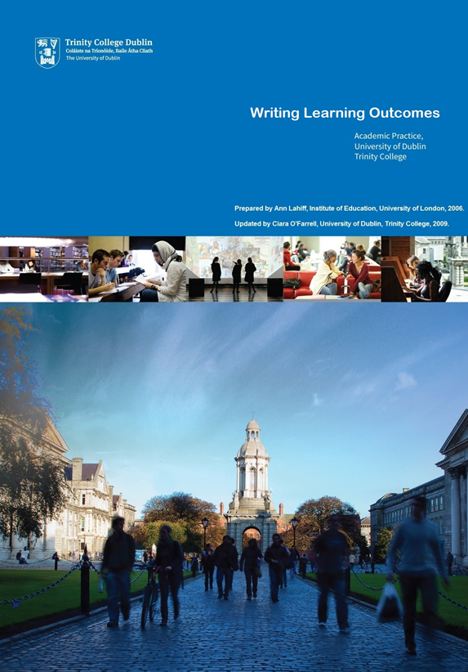 | TCD writing learning outcomes (includes a CHECKLIST) exercise (updated 2009)  https://www.tcd.ie/CAPSL/assets/pdf/Academic%20Practice%20Resources/Writing%20Learning%20Outcomes.pdf
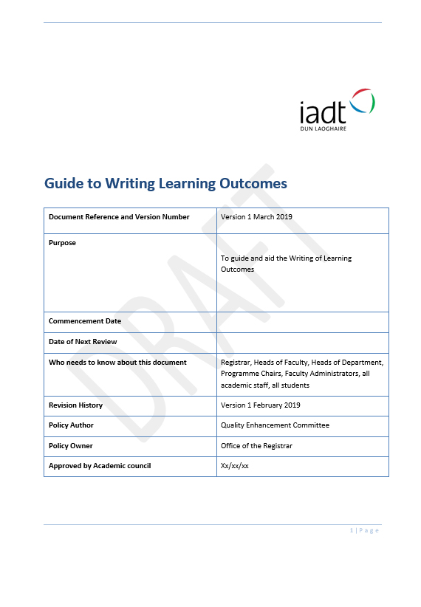 | IADT Learning Outcomes pdf (2019)  www.davidquin.ie/DRAFT IADT Learning outcomes Guide 29-3-19.pdf
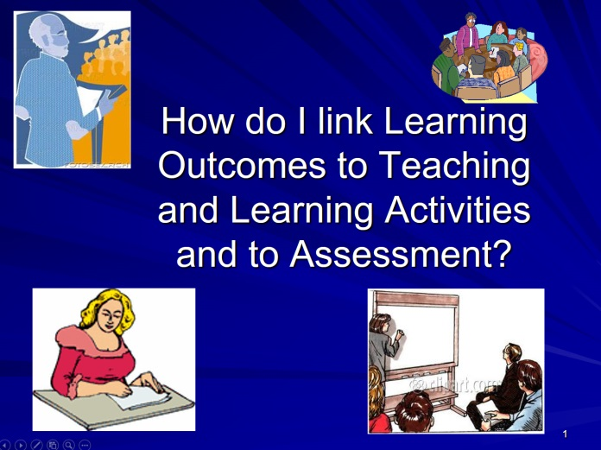 | Declan Kennedy aligning LOs with ASSESS etc Talk 2 DkIT Sept 2012  Includes Dublin Descriptors  https://www.dkit.ie/centre-learning-teaching/information-staff/learning/writing-learning-outcomes-designing-modules-learning
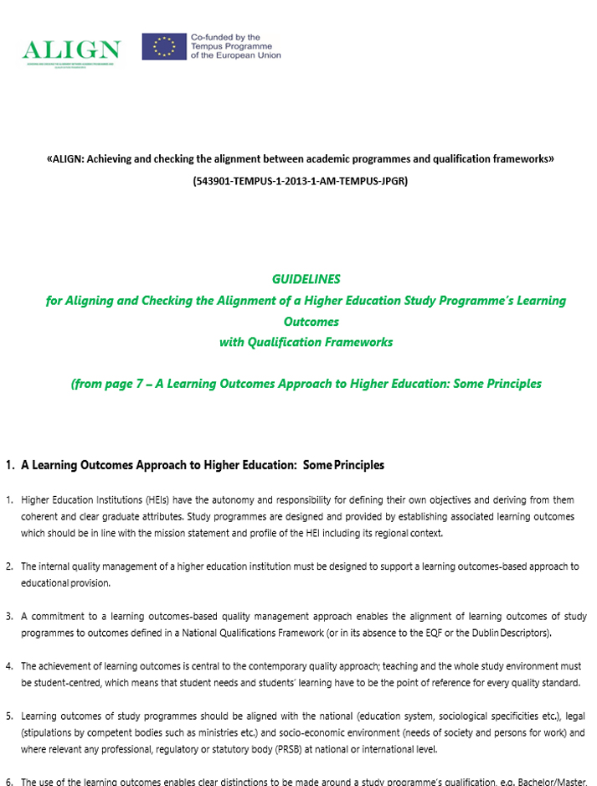 | www.davidquin.ie/ALIGN Guidelines - from page 7 - A Learning Outcomes Approach to HE - some principles.pdf


WP3 European Curriculum Design TOOLKIT

Learning Outcomes TWO: A TCD Learning Outcomes Checklist

From page 36 of TCD’s ‘Writing Learning Outcomes’
Prepared by Ann Lahiff, Institute of Education, University of London, 2006
Updated by Ciara O’Farrell, University of Dublin, Trinity College, 2009

Activity 1: learning outcomes checklist

 | Answer | Action?
- Are you happy that outcomes, as currently expressed, reflect what you would want your students to be able to do, think or feel by the end of their course of study?
- To which domains do your learning outcomes belong—doing (psychomotor), thinking (cognitive) and/or feeling (affective)?
- Is the balance of learning outcomes across domains appropriate for the type of programme/course you are teaching?
- Are the outcomes expressed appropriately:
- Are they written in the future tense?
- Are they clear and concise?
- Are they limited in number?
- Do they use relevant verbs?
- Do they specify an appropriate level of learning?
- Are you confident that the outcomes ‘fit’ with the level descriptors of the award or programme/course?

From page 36 of TCD’s ‘Writing Learning Outcomes’
Prepared by Ann Lahiff, Institute of Education, University of London, 2006
Updated by Ciara O Farrell, University of Dublin, Trinity College, 2009

https://www.tcd.ie/CAPSL/assets/pdf/Academic%20Practice%20Resources/Writing%20Learning%20Outcomes.pdf

Programme Learning Outcomes
‘Now set the Study Programme Aims. In Bath Spa University, we usually have 8 Programme Aims – but this may well be determined by your university and external regulations, graduate attributes, national, international and professional requirements. As Rónán said ‘start at the end’ – what will your graduates look like? According to my university regulations, I have 4 years for my study programme. What do I want my graduates to have learned in those 4 years? What ‘graduate attributes’ do I want to develop? How will my students’ learning be structured and progressed over the 4 years of the study programme? Be fair and honest about the Programme Aims. What do you want your students to do? Be a little bit distinctive if you can – different study programmes should have slightly different programme aims.’

Paul Hyland – DESTIN Kyiv conference 14th May 2019

The ‘Learning Outcomes One: What are Learning Outcomes? Section of the DESTIN toolkit tells us…
Learning Outcomes are statements of the minimum of what is expected that the student will be able to do as a result of a learning activity (Jenkins and Unwin, 2001). They are an explicit description of what a learner should know, understand and be able to do as a result of learning (Bingham, 1999). Learning Outcomes must focus on what the student needs to achieve to attain a passing standard, rather than the content of what has been taught.

Programme Learning Outcomes (PLOs) are statements of the minimum a learner is expected to know, understand or be able to do on successful completion of the entire study programme.

In European Curriculum Design, it is usual for there to be a small number of Programme Learning Outcomes. In Ireland in 2019, it is usual for a study programme to have 10 to 15 Programme Learning Outcomes. In the UK, 8 Programme Learning Outcomes are now the norm.

Finally - Programme Learning Outcomes should be written in plain, simple language. They should be easily understood by an APPLICANT to your study programme.

Learning outcomes inform potential candidates and employers about the programme and ensure consistency of outcomes across subjects and disciplines.

Learning outcomes:

- Guide students in their learning, in that they explain what is expected of them
- Are statements of what is expected that the student will be able to do as a result of a learning activity (Jenkins and Unwin, 2001)
- Are an explicit description of what a learner should know, understand and be able to do as a result of learning (Bingham, 1999)
- Must focus on what the student needs to achieve to attain a passing standard. Rather than the content of what has been taught.
- Assist in the design of appropriate learning, teaching and assessment strategies
- Focus on student behaviour and use specific action verbs to describe what students are expected to do

Refer to the ‘Learning Outcomes One: What are Learning Outcomes? Section of the DESTIN toolkit for more information…

https://quindpdp.blogspot.com/2019/05/destin-wp3-toolkit-learning-outcomes-one.html

Table Mapping a Programme against a National Framework of Qualifications

This table is taken from the 2015 version of IADT’s DL832 Animation (BA (Hons) study programme. The Table maps the study programme (including PLOs. Teaching strategies, Assessment, Modules and Module Learning Outcomes) against the Irish NFQ at Batchelor Level (Level 8 in Ireland).

Animation mapped against the National Framework of Qualifications

NFQ Level  8 | Programme Learning Outcomes | Suggested Teaching Strategies | Assessment | Modules | Module Learning Outcomes
Knowledge Breadth | - Animate, i.e. the production of moving image media on a 'frame-by-frame' basis  - Critically analyse the work of other animators and filmmakers, and apply this critical approach to their own work | - Teaching is delivered via a combination of lectures, demonstrations, seminars, visual delivery and studio work.  - Teaching is supported through various resourcing mechanisms such as online databases, image banks and sound libraries, IADT’s VLE and LILRC and programmes archives of films and previous project work. | - Panel assessment of film and digital work produced by students  - Oral and AV presentations of film and research work  - Written essays and supporting materials, derived from research and analysis  - Assessment is centred around the student’s understanding of the practice of animation and their engagement with their own work. | - Digital Skills for Animation  - Life Drawing  - Design for Animation Production  - Animation Principles  - Storyboarding and Layout  - Critical and Contextual Studies (all year modules)  - Towards Professional Practice | - Demonstrate a sound foundation in the basic digital skills necessary for animation production  - Demonstrate the use of a wide range of media used in Drawing  - Develop the ability to produce animated sequences using experimental animation techniques  - Demonstrate the necessary integration of the processes used in the making of an animated film  - Develop a basic understanding of the business issues relating to animation production  - Engage with live industry-standard project briefs, placements or internships and to produce project work based on such briefs or placements  - Acquire a working knowledge of current and historical issues and frameworks in the field of animation visual culture
Know-How & Skill  Range | - Apply the relevant knowledge, skills, tools, and professional practices specific to character animation and animation production.  - Identify their own specific skills and areas of specialization, and use these in multiple contexts | - Teaching in this area revolves around students’ refinement of imagery, skills and concepts with an eye to developing a fully realised aesthetic.  - This is accomplished through guided research, individual tutorials, seminar and group screenings | - Presentation of increasingly professional standard work  - Group projects which mimic industry conditions  - Research, written and visual, which investigates increasingly personal approaches to the field and its concerns | - Storyboarding and Layout  - Research and Concept Development  - Towards Professional Practice  - Research Seminar and Thesis Preparation  - Pre-Production and Content Development | - Demonstrate familiarity with the techniques and expressive qualities of a variety of different animation media  - Demonstrate personal expression, individual ideas, and the expression of these ideas through a variety of choices of relevant animated media  - Present a self-selected research topic for peer/tutor review and analysis  - Selection of, pre-production and production of a substantial animation project  - Have increased their understanding of how critical approaches to film can be profitably integrated with their studio practice can confidently give an oral presentation of their work
Know-How & Skill Selectivity | - Plan, schedule, resource and project manage an animation project from concept to finished production.  - Source relevant research, visual and textual, which will broaden and support animation production aims  - Exercise judgement in choosing material and media appropriate to project parameters and briefs | - Guiding students through the concepts and development from storyboards to finished film, in the form of lectures, tutorials, seminars and presentations.  - Encouraging individualised goal setting which also meets the goals in the project briefs | - Project briefs progressively emphasise personal engagement with research and topic areas, encouraging students to specialise their interests. Films, presentations, group projects and essay work are all aspects of this area. | - Storyboarding and Layout  - Animation Principles  - Pre-Production and Content Development  - Final Year Project  - Research Seminar and Thesis Preparation  - Thesis | - Generate, change and develop original project ideas using brainstorming and concept development techniques  - Demonstrate a capacity for independent learning  - Have produced an original pre production document approaching industry standard  - Demonstrate a knowledge of the animation production processes from concept to completion  - Have produced original work in a format of their choice  - Demonstrate a critical approach to solving animation production problems
Competence  Context | - Use animation in a range of professional contexts, including character animation, pre-production design, inc. storyboarding, and digital animation production  - Present a professionalized portfolio of animation production content via the web and other resources | - The pedagogical strategies employed in this regard provide students with an increasing set of opportunities for exploration and choice within project guidelines.  - In third and fourth years especially, the projects briefs place an increasing emphasis on decision making and individual direction of project – these frameworks are integrated into all assessment strategies. | - Project briefs progressively emphasise personal engagement with research and topic areas, encouraging students to specialise their interests. Films, presentations, group projects and essay work are all aspects of this area. | - Storyboarding and Layout  - Pre-Production and Content Development  - Final Year Project  - Portfolio | - Demonstrate that they have developed an ability to critically evaluate their work and the work of others made in this module  - Have developed a firm understanding of the concept, design and integration of disparate digital techniques and technologies in the animation production process  - Demonstrate the ability to prepare, pitch and present project work  - Develop an authoritative understanding of the topic of enquiry  - Demonstrate a knowledge of the animation production processes from concept to completion
Competence  Role | - Work effectively in professionalized groups | - Creating opportunities through clearly structured group projects which allow students to develop their identities as professional practitioners  - Encouraging collaborative strategies in the completion of individual film projects | - Film projects centre around industry practices requiring sound collaborative skills | - Towards Professional Practice  - Production Preparation  - Final Year Project | - Demonstrate group-working  - abilities  - Engage with live industry-standard project briefs, placements or internships and to produce project work based on such briefs or placements  - Have developed an understanding of animation specific industry standards and practice  - Demonstrate a knowledge of the animation production processes from concept to completion
Competence  Insight | - Integrate theory and practice in the production of animation | - Balancing lectures, studio work and individual advisement for each student with a view to developing their particular strengths and potential | - Assessment in project work, essays and presentations throughout the programme, as students move to increasingly individual and integrated solutions to the tasks they are set | - In essence, all modules in the programme contribute to creating students who approach their work and their world with a sense of their strengths, their relationships to other practitioners and an awareness of the relevance and position their field within wider cultures | - Module learning outcomes across the programme are framed so that students are presented with multiple pathways and opportunities for insightful learning and self awareness, encouraging personal as well as professional growth

The Assessment of Students

From ‘Developing Student Centred Learning’ (powerpoint presentation)
Paul Hyland & Inna Pomorina
THE ANNUAL TEMPUS CONFERENCE
ENHANCING THE QUALITY AND RELEVANCE OF STUDENTS’ LEARNING EXPERIENCE
Moscow, Russia, November 13 - 14, 2015
p.hyland@bathspa.ac.uk
i.pomorina@bathspa.ac.uk

Importance of Assessment to Student Learning
It exercises a powerful influence on
What students learn:
In terms of (a) their knowledge, skills and professional attributes that students acquire from their course of studies; and (b) what students learn about themselves – their personal development – including their individual abilities, values, needs and achievements, which critically affect students’ self-worth, confidence and aspirations.
How much they learn:
Most students spend most of their time on assessed tasks. So the number, nature and demands of assessment tasks affect students’ total study time and ‘time to task’.
How they learn:
The nature of the assessment tasks (eg whether solitary, collaborative, authentic, creative) directly affects the nature of a students’ learning experience. This critically affects students’ perceptions of their learning environment and heir approach to learning (eg deep or surface). A student’s approach to learning then exercises a powerful influence on the quality (and enduring value) of her/his learning outcomes.
How effectively they learn:
The number and timing of assignmentsdirectly affects the distribution of student effort in the course of a year. An uneven distribution of effort may lead students to adopt a surface approach to learning at busy times (eg when there is submission ‘bunching’), and consequently to low-quality learning outcomes.
7 Propositions for Assessment Reform
Assessment is most effective when …
- assessment is used to engage students in learning that is productive
- feedback is used to actively improve student learning
- students and teachers become responsible partners in learning and assessment
- students are inducted into the assessment practices and cultures of higher education
- assessment for learning is placed at the centre of subject and programme design
- assessment for learning is a focus for staff and institutional development
- assessment provides inclusive and trustworthy representation of students’ achievement
Adapted from Boud, D. (2010), Assessment 2020. Australian Learning and Teaching Council.

10 Key Conditions to ensure assessment enhances student learning
- Tasks capture sufficient study time (time on task: Berliner)
- Tasks orientate students to allocate time & effort evenly across course and on most important things
- Tasks engage students in, and reward them for, high-quality learning activities
- Sufficient feedback is provided; often enough and in enough detail
- Feedback focuses on students’ learning, rather than on marks or students themselves
- Feedback is timely (still of use)
- Feedback is linked to purpose of assignment and assessment criteria
- Feedback is understandable to students
- Feedback is received by students and attended to
- Feedback acted upon by students to improve future work/assessments
Adapted from Gibbs , G. (2005) Conditions under which assessment supports students’ learning, Learning and Teaching in Higher Education, 1(1), 3-31.

Importance of Developmental Feedback
- Now widely recognised that feedback exercises a powerful influence on the quality of students’ learning experiences and achievements.
- Feedback on the progress of students’ learning may be regularly embedded in many kind of teaching and learning activities.
- Only by knowing what, how, and how much progress students (each and all) are making in their learning can we as teachers understand the impact/effects of our various teaching activities and adjust these to optimize student learning.
- Providing high-quality developmental feedback is therefore a hallmark of excellence in teaching.
We aren’t teaching unless students are learning …
So, we want more developmental feedback for our students and ourselves …
How best can we go about it?

101 Ways and Kinds of Developmental Feedback
Developmental Feedback needs to provide students with practical advice that enables them to understand how they can make progress.

- It can be on summative assignments or formative exercises/tasks.
- It can be in or out of class; for whole cohorts, groups or individuals;
- It can be oral, visual or written.
- It can be provided by peer-groups, mentors, teachers, professionals, public …
- It can be face-to-face or online, using a wide range of readily-available technologies.
- It needs to be regular, criteria-related, legible, understandable, practical, timely, useable, and it could be creative, imaginative, etc.
It may be
- Diagnostic (tutors identify weaknesses and remedies);
- Ipsative (charting progress from previous feedback; ‘personal best’);
- Student-led (students identify what developmental feedback they want);
- Feed-forward (directly aimed at a future assignment, or part of a ‘staged’ process)
- Peer-based (within a peer-review process. See D. Nicol references)

Task: A Few Questions
- How many summative assignments does your programme have?
- What kind of learning experiences do these require and capture?
- How many assignments do you need to measure students’ achievement?
- How many formative exercises/tasks does your programme have?

Some Guidelines for Assessments
1. All assessments should be valid, reliable and fair.
Some assessment tasks are of limited validity, not actually testing what they claim to be.
2. Assessments should test attainment of Intended Learning Outcomes.
Teaching and learning activities should provide students with opportunities to develop their knowledge and abilities in order to undertake the assessed work. This is called ‘constructive alignment’ (John Biggs).
3. Assessments should develop students’ ability to manage their own learning.
This means that students will need to develop understanding of how to measure and address their own learning needs and achievements (meta-cognition). Enabling students to become autonomous should not be confused with solitary learning.
4. Assessments should engage students and reward high-quality learning activities/outputs.
Tutor feedback should measure/grade performance (against explicit criteria) and provide practical advice on how to improve.
5. Formative assignments (pre-assessment exercises) may often be small scale & low stakes.
They can be embedded into normal learning and teaching activities. Tutors and peers can provide developmental feedback throughout a course. Formative exercises do not need even to be ‘marked’ or ‘graded’.
6. Each kind of assessed task should have its own assessment criteria.
For example, we would expect the assessment criteria for essays, group fieldwork projects, seminar management/presentations, knowledge tests, websites, and portfolio work to be distinctive, reflecting the particular nature of the learning outputs to be tested.
7. The processes of assessment may involve elements of self-reflection, peer-review & assessment, tutor criticism, assignment revision, external professional observation, etc.
This should not be confused with marking or grading. Normally, marking is the responsibility of the teacher, but all students can often be involved in the processes of ‘assessment’. Ensuring that assessment processes are transparent and participatory will help students to understand goals and standards, and to develop their abilities to manage their own learning. Where the marking/grading of students’ work involves other students/parties, additional attention should be paid to ensure the integrity and accuracy of the marking processes and outcomes.
8. The volume, variety and timing of assignments across a degree should be managed to help students plan their studies and use feedback to develop abilities.
Too many assignments may encourage a surface approach to learning; too few may lead to inadequate effort/time on task. Too much variety may reduce students’ ability to realise improvements; lack of variety may fail to engage and capture the range of students’ abilities and achievements. How tasks are related (when and in what order they are undertaken) will affect the utility of feedback.
9. Tutors must keep an appropriate summary account (online or on paper) of the assessment feedback (as well as the marks) provided on all summative work.
This is good professional practice. It can help teachers and teaching teams to reflect upon and monitor the impact and effectiveness of their teaching, and adapt their teaching plans in light of student learning.

Quick Guide to Improving Assessment
Turn the Lights on!
- Work WITH students to review & align all aspects of assessment in a programme.
- Put assessment at the heart of pedagogical practice (learn to love it & make it loveable)
- Increase discussion and understanding of all goals, standards & assessment criteria
- Involve students as active and key participants in assessment processes
- Increase ‘formative’ exercises and all forms of developmental feedback
- Use faster, and forward-looking ‘feedback’
- Use simple technologies (e.g., Google, Jing, podcasts, screencasts, etc.)
- Develop processes of peer review/assessment (tutor marking)
- Maybe reduce summative tasks to those that really measure what’s most important
- Ensure key assessments develop students’ abilities to manage their own learning
- Use ‘authentic assessment’ (real-world assignments) in programmes

References: Assessment of Students
Boud, D. et al. (2010), Assessment 2020: Seven propositions for assessment reform in higher education. Australian Learning and Teaching Council.
Evans, C. (2013), Making Sense of Assessment Feedback in Higher Education, Review of Educational Research, 83 (1), 70–120.
Falchikov, N. (2005), Improving Assessment through Student Involvement. Routledge.
Gibbs. G. (2005), Conditions under which assessment supports student learning’, Learning and Teaching in Higher Education 1, 3-31.
Nicol, D. (2011), Developing students' ability to construct feedback. QAA Scotland, Enhancement Themes.
Nicol, D. et al (2014), Rethinking feedback practices in higher education: a peer review perspective, Assessment & Evaluation in Higher Education, 39 (1), 102-122.
Price, M.et al. (2010), Feedback: all that effort, but what is the effect? Assessment & Evaluation in Higher Education, 35 (3), 277–289
Price, M. et al. (2011), If I was going there I wouldn’t start from here: a critical commentary on current assessment practice, Assessment & Evaluation in Higher Education, 36 (4), 479–492.
For a tool designed ‘to help universities to review current policy and practice in assessment and feedback, with a view to radically rethinking the institution’s assessment strategy’, see A Marked Improvement: Transforming Assessment in Higher Education (HEA, 2012). www.heacademy.ac.uk/resource/marked-improvement
For video and online resources on ‘Effective Assessment in a Digital Age’, see JISC site: www.jisc.ac.uk/assessresource
For UK-based projects designed to improve assessment and feedback practices:
- TESTA (Transforming the Experience of Students through Assessment) www.testa.ac.uk
- The REAP site (Re-engineering Assessment Practices) on the need for students to learn through ‘Peer Review’: www.reap.ac.uk/PEER.aspx

DESTIN WP3 TOOLKIT - PROGRAMME DESIGN FOUR – sample charts, tables and matrices
http://quindpdp.blogspot.com/2019/05/destin-wp3-toolkit-programme-design-four.html
Here we show some charts, tables and matrices which may be useful for you to consider when explaining your study programme in your revised documents. The documents here are invented! Concentrate on the form of the documents, rather than on the content presented!
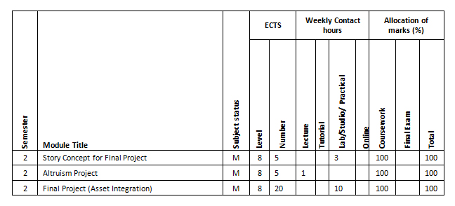
Matrix mapping Modules against ECTS, contact hours and allocation of marks
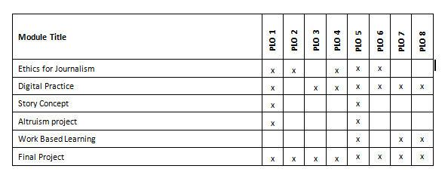
Matrix mapping Modules against Programme Learning Outcomes

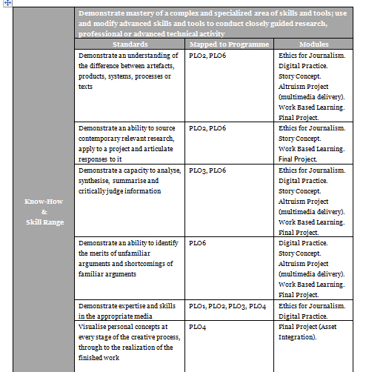
Matrix mapping standards, PLOs and modules
(this is an invented matrix, so apologies for any non-correlations - focus on the format of the Matrix, rather than the content!)

WP3 European Curriculum Design TOOLKIT

Terminology (DESTIN and SSU ICM) - FEB 2019 005
Thanks to The Sumy State University team for their work on this Glossary which originally emerged from work done by Iryna Skliar for Tempus ALIGN and was further developed through inter-project coaching in an IADT-SSU KA1 mobility. Special thanks to SSU’s Iryna Skliar and Konstantin Kyrychenko for leading this work.

See the EU Commission’s own Glossary at… http://ec.europa.eu/education/ects/users-guide/glossary_en.htm

Irish Term | Ukrainian Term | Definition
Study Programme | Study Programme - an integrated set of educational components (study subjects, disciplines, individual assignments, control activities, etc.), planned and organized in order to achieve established learning outcomes Law of Ukraine On Education  Study programme (vocational, academic or creative) is a set of education components correspondent to a particular level of higher education within a speciality that defines requirements to an education level of individuals who may commence study under this programme, list of courses and their logical sequence in learning and instruction, number of ECTS credits required as well as expected learning outcomes (competencies) that learners are required to demonstrate at a particular level of higher education;  Law of Ukraine On Higher Education | a programme of study over a period of years (stages), culminating in an award (BA, MA etc.)
Course | - course - completed study period during one academic year  academic course – completed period of studying of HEIs students during one academic year  - a synonym of discipline
Discipline | Educational component containing pedagogically adapted system of concepts about phenomena, laws, methods, etc., in any field, which contains the required level of formation of learning outcomes
Module | - the component of the study programme, which involves certain learning activities and has the same or multiple credits ECTS (defined component of an academic plan (study programme) within the system that involves, certain kinds of studying of a HEI student and obtains the same or multiple credits)  (from 2016, but term "discipline" is more commonly used  - We have official term “module-attestation cycle”, which we call “module” – is the stage within academic year -1/4 academic year, 1/2 semester (before 2016, but we use it in this meaning now) | Stages of a Study Programme may be divided into discreet Modules. Each Module is assigned to ECTS credits (5 credit module, 10 credit module, 20 credit Major Project module etc.)
We have an generic (umbrella) term for module and discipline | Study component is a self-sufficient and formally structured unit of the curriculum (module, discipline, training etc.), which has a clear list of learning outcomes, relevant assessment criteria and credits ECTS
Stage | We do not have a similar term in use. Perhaps “stage” is an alternative to our "academic year" | Each academic year of a study programme is called a Stage (Stage 1, Stage 2, Stage 3 etc…) Each fulltime Stage is assigned to 60 ECTS credits
Module Component | The term is not officially defined. However, we have actually used the components of the module after switching to 5 credits ECTS | Modules may be broken down into separate components. Module Components may be taught and assessed by separate lecturers. Each Component Grade may contribute to a module’s overall alpha grade.
Assessment | The procedure to determine whether ILOs are achieved. Procedure for determining the achievement of the results of higher education by students  Usually the term "control" is used within Ukrainian higher education
Formative Assessment | The term is not officially defined and is not actually used
Summative Assessment | The term is not officially defined. In fact, summative assessment (in its traditional meaning) is called "control" or "attestation"
Continuous Assessment - CA | Current control - control of student's performance of certain types of learning activities and assessment of variety of current work at laboratory, practical, seminar classes, studying theoretic material and performing individual tasks.
Grade or Alpha Grade | The grading scale runs from 0 to 100 and the marks have the following meanings: (http://www.sumdu.edu.ua/int/en/10-international/938-grading-system-of-sumy-state-university.html
  Marks | National grade | ECTS grades
  0-34 | fail | F
  35-59 | unsatisfactory | FX
  60-63 | sufficient | E
  64-73 | satisfactory | D
  74-81 | good | C
  82-89 | very good | B
  90-100 | excellent | A

Irish Term | Ukrainian Term | Definition
Workload  student workload  lecturer workload | Student workload - typical SW that consists of contact hours and self-study with. SW is 45 academic hours per week for a full-time student.  Student workload is accounted and planed in ECTS credits.  ECTS credit shall mean a unit used to measure workload of a learner engaged in higher education required to achieve pre-defined (expected) learning outcomes. One ECTS credit equals to 30 working hours. Workload of one year of full-time study is generally represented by 60 ECTS credits.  lecturer workload - working time of academic staff includes time spent for scientific inquiry, research, consultancy, expert and organizational work and other job responsibilities. Working time of academic shall equal 36 hours per week.  Upper limit of full-time equivalent workload of academic staff may not exceed 600 hours per academic year. *  *This regulation is only about teaching (without research, consultancy, expert and organizational work)
Student Survey | At the SSU we use it for evaluation of the educational activities quality
Student Centred Learning (SCL) | The term is not officially defined. Therefore, SCL is used in different meanings within the academic environment
Learning Outcomes, LOs  Minimum Intended Module Learning Outcomes (MIMLOs)  Minimum Intended Programme Learning Outcomes (MIPLOs) | Learning outcomes shall mean an aggregate of knowledge, abilities, skills and other competencies that students have attained in a set of educational experiences under a particular vocational or academic programme which may be identified, numerically assessed and measured.  MIMLOs, MIPLOs are not officially defined. In fact, these terms ("minimal ...") are not used. We have just begin to use the LOs based approach | Learning Outcomes or LOs are what the student is expected to LEARN on successful completion of a programme, a module or even a module component.  Minimum Intended Module Learning Outcomes (MIMLOs)  Minimum Intended Programme Learning Outcomes (MIPLOs)
Levels of Award | According to the Ukrainian qualification framework, Bachelor is one level of Award (6th level of NQF), so we do not divide BA (BSc) by levels. Maser is one level of Award (7th) | Levels of Award indicate how the Study Programme relates to the NFQ and the EFQ. (In Ireland, BA (Ordinary) is Level 7. BA(Hons) is Level 8. MA is Level 9 and PhD is Level 10)
Peer Review | The term is not officially defined and is not actually used
Benchmarking | This is an approach to planning activities, which means a continuous process of assessing the level of services and working methods of other actors. The process of discovering, studying and evaluating all the best in other organizations in order to use the knowledge gained in the work of our organization

Study Programme - a programme of study over a period of years (stages), culminating in an award (BA, MA, etc.)
Stage – each academic year of a study programme is called a Stage (Stage 1, Stage 2, Stage 3 etc…) Each fulltime Stage is assigned 60 ECTS credits
Module – Stages of a Study Programme may be broken down into discreet Modules. Each Module is assigned ECTS credits (5 credit module, 10 credit module, 20 credit Major Project module, etc.)
Modules may be broken down into separate components. Module Components may be taught and assessed by separate lecturers. Each Component Grade may contribute to a module’s overall alpha grade.
Modules or module components can be organised across Programmes. The assessment and grades for any student work done must be fed back to the individual students and to their programmes.
Learning Outcomes or LOs are what the student is expected to LEARN on successful completion of a programme, a module or even a module component.
Minimum Intended Module Learning Outcomes (MIMLOs)
Minimum Intended Programme Learning Outcomes (MIPLOs)
Levels of Award indicate how the Study Programme relates to the NFQ and the EFQ. (In Ireland, BA (Ordinary) is Level 7. BA(Hons) is Level 8. MA is Level 9 and PhD is Level 10)

Irish Term | Ukrainian Term | Definition
Student Survey | At the SSU we use it for evaluation of the educational activities quality
Lecturer | Person who is responsible for the module (discipline) delivery (content, assessment, teaching/learning methods)
Programme Team | Assurance Unit of Specialty - a group of pedagogical, scientific and pedagogical and/or scientific staff for whom the educational institution is the main place of work and are responsible for the implementation of educational programs in a specialty at certain levels of higher education; project group - defined by the order of the head of the educational institution a group of pedagogical, scientific-pedagogical and /or scientific staff who are responsible for the initiation of educational activities in a specialty at a certain level of higher education.
Curriculum | The document that is formed on the basis of the educational program and the structural-logical scheme of studying and includes a list of compulsory and selective educational components, the sequence of their study, the form of conducting educational materials, their number, the schedule of the educational process, the forms and means of conducting current and final control
Content | Educational content – a science-based and pedagogically formed system, formed system of studying materials, the assimilation of which gives the person the opportunity to obtain a certain qualification at different levels of higher education.
Exam | Exam the form of semester control of the results of a student's education from a separate educational component (usually from a discipline) for a semester, conducted as a control measure

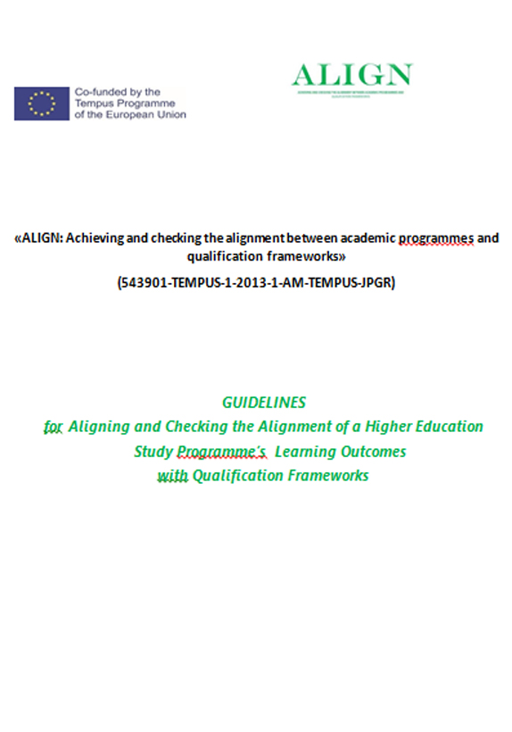 | ALIGN Guidelines for Aligning or Checking the Alignment of an academic programme V1.0 Final-1.pdf

The Module Descriptor – as presented by IADT’s Rónán O Muirthile on 13th May 2019 in Kyiv

Course Title DL129

Certificate in Research Methods for the Creative Practices

6.4.1 Headline Information about the Module
NFQ Level |  | Term |  |  | Stage |  |  |  |  | Module Code |  |  |  |  |  |  | Module Credits |  |  | Credit Unit
9 |  | 1 |  |  | 6 |  |  |  |  |  |  |  |  |  |  |  | 10 |  |  | ECTS
Department Title |  |  |  |  | Department of Film & Media
Parent Programme(s) |  |  |  |  | NA
Entry Requirements |  |  |  |  | Learners must have achieved a primary honours degree at 2.2 standard, higher, or equivalent.  Applicants who do not meet the academic entry requirements, but can demonstrate significant professional experience at an advanced level may be considered for admission in exceptional circumstances (under the Recognition of Prior Learning policy).
Pre-requisite Modules |  |  |  |  | N/A
Co-requisite Modules |  |  |  |  | N/A
Capstone Module |  |  |  |  | Yes |  |  | - |  |  |  |  |  | No |  | No
Learning Modes |  |  |  |  | A mix of: Full Time/Online/Blended & Self Directed
Duration |  |  |  |  | A total of 15 weeks within one academic term  2hrs per week directed lecture (1:30) or workshop (1:10)  1 hour per week 1:1 tutorial or (1:5) research seminar groups  (An alternative delivery model provides for an intensive 30hour x 1week block of teaching with additional 1:5 or 1:1 blended supports including e-learning and online tutorial support)
Average Contact Per Week |  |  |  |  | 4 hours is the average contact hours per week over duration of module
Maximum number of Learners per centre |  |  |  |  | 30
Module-specific physical resources and support required per centre (or instance of the module) |  |  |  |  | - One Classroom / for 2 hrs per week with a capacity of 15 students & 1 lecturer  - Library Access for 9 hrs per week  - Outside of block teaching period 9hrs per week library access  - VLE & Digital resources
Specification of the qualifications and experience required of staff |  |  |  |  | Course co-ordinator/programme chair qualified to at least or equivalent level 9 qualification and with a relevant Third Level Teaching and Learning qualification and/or equivalent relevant and comparable professional experience.  Additional tuition provided by relevant research experts who supervise workshops and seminars on specific areas.
Analysis of Required Learning Effort
Effort while in contact with staff for each student over the course of the module
Classroom, Lectures & Practical Demonstrations |  |  | Mentoring & Small Group Tutoring |  |  | Other - Specify Activity |  |  |  |  | Directed E-Learning (Hours) |  | Independent Learning (Hours) |  |  |  | Field Research |  | Summative  Assessment |  | Total Effort
2 | 1:15 | 30 | 15 |  |  | 0 |  |  |  |  | 10 |  | 100 |  |  |  | 40 |  | 5 |  | 200
Distribution of Assessment (within this Module)
Continuous Assessment |  |  | Supervised Project |  |  |  |  |  | Proctored practical examination |  |  |  | Proctored written examination |  |  |  |  | Professional Practice |  |  | Total
40 |  |  | 60 |  |  |  |  |  | NA |  |  |  | NA |  |  |  |  | NA |  |  | 100%
Module Aims and Objectives
6.4.2 Global Aims and Objectives |  |  |  | The aim of this module is to build a culture of interdisciplinary research that is practice led and practice based throughout the institute at level 9.  This module will allow learners to develop practice based and or practice led research skills and to apply them to a relevant discipline area. Having formulated a topic for enquiry, they will then synthesise a range of research skills and methodologies allowing them to expand and deepen their approach to their creative practice.  Practice-based research is “the pursuit of research which is centrally predicated on realising actual practice within the arts”.*  The objective is to provide learners with the ability to conduct informed independent research in an interdisciplinary context informed by the most recent and contemporary debates within their own specific discipline area or area of expertise.  Internationally the norm has been to describe post-graduate research in which an artefact is the outcome as 'practice-based', while post-graduate research which interrogates methods, methodologies, theoretical frameworks of practice with the outcome being a thesis and an artefact as 'practice-led'. The objective of this module is to prepare learners for both.  * Good Practice in the Quality Assurance of Arts Research Degree Programmes by Practice. Ireland. HETAC, 2010
6.4.3 Minimum Intended Module Learning Outcomes (MIMLOs |  |  |  | On successful completion of this module, the learner will be able to:  - Demonstrate an ability to conduct informed independent research in an interdisciplinary context informed by the most recent debates within a specific discipline area.  - Formulate a research question using appropriate methodologies.  - Synthesise a range of research strategies & methodologies relevant to a practice based discipline.  - Evaluate the applied research processes appropriate to discipline specific practices.  - Present research findings in an agreed and appropriate format.  - Evaluate the efficacy of research findings in furthering the advancement of a relevant discipline.
6.4.4 Rationale for Inclusion of the Module in the Programme and its contribution to the overall IPLOs |  |  |  | This module enables the learner to demonstrate their skills/ knowledge and competencies in academic research for a practice based creative discipline.  The module learning outcomes complement and support a substantial number of other modules at this stage across a range of programmes and therefore contribute significantly to the learner achieving the Intended Programme Learning Outcomes.
6.4.5 Information Provided to Learners about the Module |  |  |  | The module is supported and presented to the learners by the programme chair/coordinator & module leader as the principal points of contact  We will communicate module specific information to students in the following ways:  - A learner handbook provided at the beginning of the project  - Online & VLE platforms  - E-learning resources  - Briefing papers that include all the relevant information required by the learner to complete the project including the following  - lesson plans,  - assessment strategies/schedules,  - assessment rubrics  - reading lists  - E-resources
6.4.6 Module Content, Organisation and Structure |  |  |  | The module is informed by current research in transdisciplinary research contexts in particular as summarised by Gray and Malins Visualising Research( Ashgate 2004)  http://www.upv.es/laboluz/master/seminario/textos/Visualizing_Research.pdf  The module takes as its first principle;-  “Professional practice qualifies as research when it can be shown to be firmly located within a research context, to be subject to interrogation and critical review and to impact on or influence the work of peers, policy and practice.”  The content of the module then explores this principle using AHRB UK’s definition of research process involving three key features;  • clearly-articulated research questions to be addressed through the research, and a related series of objectives which will enable the questions to be explored and answered  • the specification of a research context for the questions, and a rationale for why it is important that these particular questions should be answered or explored; this description of context should make clear what other research is being or has been conducted in this area; and what particular contribution this particular project will make to the advancement of creativity, insights, knowledge and understanding in this area  • the specification of appropriate research methods for addressing and answering the research questions, and a rationale for the use of particular methods.  The modules is structured as six sequential phases each of which has a specific topic or focus as described below  - Mapping the Terrain: methods of contextualizing research.  - Locating Your Position: methods of orienting and situating research.  - Crossing the Terrain: establishing appropriate research methodologies.  - Interpreting the Map: methods of evaluation and analysis.  - Recounting the Journey: recognizing new knowledge and communicating research findings.  Each phase is taught as a combination of lecture/seminar/ discussion groups referring to appropriate research concepts or method and examples  The module will require learners to engage in the following activities:  - The formulation of a research enquiry or an appropriate topic for analysis  - The acquisition of the necessary skills to conduct appropriate academic research, using appropriate methods - qualitative and/or quantitative  - Identify, construct and justify an appropriate method for enquiry  - Gather, evaluate and interpret data and evidence  - The synthesis of critical thinking skills, the integration of findings and structuring of arguments as part of an enquiry  - Evaluate ethical guidelines appropriate for 3rd level research  - Engage with institutional ethics procedures as may be relevant to the learner’s research  - Present findings, insights or data in a manner and format relevant to the enquiry  Please note: The module can address any research enquiry with outputs in any form so long as they meet the learning outcomes.
Term/Week No |  |  |  | Priority Topics/Classroom Activity/Student Activity |  |  |  |  |  |  |  |  |  |  | Modes of Learning and Self-Directed Study Strategies
1 |  |  |  | Project Briefing, Course Introduction |  |  |  |  |  |  |  |  |  |  | Lecture, Workshop, Discussion
2 - 3 |  |  |  | Phase 1  - Introduction to practice based and practice led research & methodologies  - Framing a research enquiry  - Gathering & Evaluation evidence |  |  |  |  |  |  |  |  |  |  | Workshop, tutorials, demonstration
4-6 |  |  |  | - Research & interrogation of methodologies  - Formulate topic for research |  |  |  |  |  |  |  |  |  |  | Discipline Specific seminar groups
7 |  |  |  | Presentation of initial findings & completion of phase 1 enquiry |  |  |  |  |  |  |  |  |  |  | Presentation - Formative Assessment and Peer Review
8 - 14 |  |  |  | Phase 2  - Research and analysis  - Independent investigation of the agreed research topic |  |  |  |  |  |  |  |  |  |  | Review, Critique, Tutorial  Discipline Specific seminar groups
15 |  |  |  | Presentation of research findings or insights  Summative Assessment and Peer Review |  |  |  |  |  |  |  |  |  |  | Review, Critique, Tutorial
6.4.7 Module Teaching and Learning Strategy (including Formative Assessment) |  |  |  | Teaching and Learning on all modules is “multi-modal” and ensures that learners are exposed to a variety of teaching methods and learning strategies.  Learners will attend scheduled lectures during timetabled hours; participate in group discussions and seminars; conduct supported field research, participate in presentations; and will be allocated sufficient independent study and practise time for individual and research group learning.  Specific Methods for this module include the use and integration of:  - Seminar and reading groups  - Workshops  - Integrated VLE activities  - Fieldwork  - Online Video / Webinars  - Visiting and guest lecturers  A range of assessment strategies provides staff with a “toolkit of assessment” for the overall programme and each discrete module. In the context of this module the summative and formative assessments may use the following available strategies; Literature review, research reports, discussion forums, learning journals, evaluation reports, projects plans, problems specifications, feasibility studies and risk assessments.  This module is predominantly assessed by the following methods:  Continuous Assessment (40%) & a research project (60%)  Indicative assignments for CA are as follows:  - Professional practice (20%)  - Initial proposal (10%)  - Presentation of preliminary research, concepts and strategy (10%)  See 6.1.13 for detailed breakdown of Module Assessment Strategy.  Research activity is structured and supported by a Module Leader (Lecturer) core Lecturing Staff, Tutor Demonstrators & Technical Support Staff.
6.4.8 Work-Based Learning & Practice-Placement |  |  |  | N/A
6.4.9 E-Learning |  |  |  | Learners make extensive use of Blackboard the Institute’s VLE. The VLE is used to disseminate briefing papers, project / course resources, reading lists and references. Formative assessment and performance monitoring and support is also provided through the VLE.  All Learners have full access to IADT’s online library and digital research resources. Additionally Lynda.com and other proprietary online learning tools/ supports (e.g. Adobe tutorials) are used extensively during the project element of this module.  Module specific digital resources are available through appropriate e-learning portals.
6.4.10 Module Physical Resource Requirements |  |  |  | - Classroom 1:30  - Seminar room 1:8  - Additional resources according to the learners disciplinary needs
6.4.11 Reading Lists |  |  |  | Essential and Recommended Reading
Casey, Catherine. Critical Analysis of Organizations: Theory, Practice, Revitalization. London: SAGE, 2002.

COLLINS, H. Creative research: the theory and practice of research for the creative industries Bloomsbury 2017

Creme, Phyllis. & Lea, Mary R. Writing at University: A Guide for Students. 3rd Edition. Buckingham, England: Open University Press, 2008.

Creswell, John. W. Research Design: Qualitative, Quantitative, and Mixed Methods Approaches. 4th ed. London: Sage, 2014. Crews‐Anderson,

Timothy. Humanities Insights: Critical Thinking and Informal Logic. Penrith, UK: Humanities‐Ebooks, LLP, 2007.

Gillham, Bill. Case Study Research Methods. London: Continuum, 2010.

Hazel Smith and Roger T Dean, Practice-led Research, Research-led Practice in the Creative Arts, Edinburgh University Press 2009

Krishnaswami, O.R., and Satyaprasad, B.G., Business Research Methods. Mumbai, IND: Himalaya Publishing House, 2010.

McGregor, Debra. Developing Thinking, Developing Learning. Buckingham: Open University Press, 2007.

McConville, Mike. Research Methods for Law. Edinburgh:
Edinburgh University Press, 2007.

Rose, Gillian. Visual Methodologies 4th Edition: New York: Sage 2016

 |  |  |  | Secondary and Supplementary Discipline specific Reading
Marcus Banks and David Zeitlyn , Visual Methods in Social Research, Sage

CROUCH, C., & PEARCE, J. Doing research in design. London [etc.], Bloomsbury Academic 2015

Marion, Jonathan S., Visual Research: A Concise Introduction to Thinking Visually, Bloomsbury; 2013

Spencer, Stephen Visual Research Methods in the Social Sciences: Awakening Visions, Routledge; 2011

Margolis, Eric M The SAGE Handbook of Visual Research Methods, Sage; 2011

Dawn Mannay, Visual, Narrative and Creative Research Methods: Application, Reflection and Ethics, Routledge; 2016

Sarah Pink, Doing Visual Ethnography, 3rd edition, Sage 2013

Seale, Clive (ed) Researching Culture and Society 4th ed. London: SAGE, 2018.
6.4.12 Specifications for Module Staffing Requirements |  |  |  | In each instance the module delivery outlined in 6.1.6. will be undertaken by a Lecturer or Associate Lecturer with, at minimum, a recognised Level 8 qualification, or equivalent, in a relevant discipline.  Industry experts will deliver specialist lecturers and workshops. They will have an active and current in-depth expertise of the contemporary media landscape in their area of speciality.  In the majority of instances, lecturing staff (AL & L) will have a Masters / Doctoral qualification.  A minimum of 40% of staff on this module will have a recognised third level teaching qualification (L9).  Learners also benefit from extensive technical support, industry input/engagements and the full complement of Student Support Services available at IADT.  See Appendix 1 Staff CVs
6.4.13 Module Summative Assessment Strategy |  |  |  | Element 1: Continuous assessment 40%  Indicative assignments for CA are as follows:  - Professional practice (20%)  - Initial Proposal (10%)  - Presentation of preliminary research, concepts and strategy (10%)  Element 2: Project 60%  Each student must complete a piece of original research of a cognate area relevant to his or her discipline. This work can form the initial phase of a larger project.  The research findings may be delivered through an appropriate and agreed method.  These may include:  A written study that includes a critical analysis (3,000 words)  Or  A Viva/Presentation (equivalent to 3,000 words)  Or  A video lecture/conference talk (equivalent to 3,000 words)  Or  A research report (equivalent to 3,000 words)  Or  An appropriate equivalent as agreed with the module lead/programme chair.
 |  |  |  | Element |  |  | Weighting |  |  |  |  | Description |  |  |  |  | LO(s) assessed |  |  | Deadline/WEEK#
 |  |  |  | #1 |  |  | 40% |  |  |  |  | Research Project proposal and schematic.  Marking Criteria as per Brief, |  |  |  |  | MLO #1, #2, #3 |  |  | WEEK1-6,
 |  |  |  | #2 |  |  | 60% |  |  |  |  | Final Project |  |  |  |  | MLO #1, #2, #3, #4, |  |  | WEEK15
6.4.14 Sample Assessment Materials |  |  |  | See Assessment briefs in a separate booklet provided.
6.4.15 Repeat Mechanism |  |  |  | A student may be required to re-sit the module in attendance however in some instances a student may repeat the critical analysis essay for the subsequent Exam Board subject to the approval of the course coordinator or relevant HOD.

MAY 2019 DESTIN WP3 European Curriculum Design TOOLKIT

Toolkit Overview – Index

WP3 European Curriculum Design TOOLKIT - TOOLKIT OVERVIEW ONE
https://quindpdp.blogspot.com/2019/05/destin-wp3-toolkit-overview-one.html
WP3 European Curriculum Design TOOLKIT - TOOLKIT OVERVIEW TWO – Index
https://quindpdp.blogspot.com/2019/05/wp3european-curriculum-design-toolkit.html

Pedagogy – Teaching and Learning Strategies

Pedagogy ONE: Core SCL and LO T+L Strategy – what students will learn, how they will learn, how do we KNOW our students are learning?
https://quindpdp.blogspot.com/2019/05/destin-wp3-toolkit-pedagogy-and-tl_59.html
Pedagogy TWO: A Basic Model of an ALIGNED Curriculum - How Curriculum Learning Outcomes, Teaching and Learning Activities and Assessment link together to allow our students to successfully learn what we intend them to learn. Student Backwash ‘why students learn what they need to PASS?'
https://quindpdp.blogspot.com/2019/05/destin-wp3-toolkit-pedagogy-and-tl_26.html
Pedagogy THREE: UCD ‘How Students Learn’ – a series of 5 short packets on pedagogical theory.
https://quindpdp.blogspot.com/2019/05/destin-wp3-toolkit-pedagogy-and-tl_17.html

Pedagogy FOUR: How can I teach and How do I assess?
https://quindpdp.blogspot.com/2019/05/destin-wp3-toolkit-pedagogy-and-tl_64.html
Pedagogy FIVE: How and Why are Programmes created?
https://quindpdp.blogspot.com/2019/05/destin-wp3-toolkit-pedagogy-and-tl_7.html
Pedagogy SIX: Peer Review of a Study Programme
https://quindpdp.blogspot.com/2019/05/destin-wp3-toolkit-pedagogy-and-tl.html

Programme Design

Programme Design ONE: Basics
https://quindpdp.blogspot.com/2019/05/destin-wp3-toolkit-programme-design-one.html
Programme Design TWO: Current (2019) trends in European Programme Design
https://quindpdp.blogspot.com/2019/05/destin-wp3-toolkit-programme-design-two.html
Programme Design THREE: Tempus ALIGN Programme Design Findings
https://quindpdp.blogspot.com/2019/05/destin-wp3-toolkit-programme-design.html
Programme Design FOUR: Charts, tables and matrices which may be useful to you to consider in the preparation of your revised study programme documents.
https://quindpdp.blogspot.com/2019/05/destin-wp3-toolkit-programme-design-four.html

Learning Outcomes

Learning Outcomes ONE: What are Learning Outcomes?
https://quindpdp.blogspot.com/2019/05/destin-wp3-toolkit-learning-outcomes-one.html
Learning Outcomes TWO: A TCD Learning Outcomes Checklist
https://quindpdp.blogspot.com/2019/05/destin-wp3-toolkit-learning-outcomes-two.html

Benchmarking

Benchmarking ONE: What is Benchmarking and Why do we benchmark?
https://quindpdp.blogspot.com/2019/05/destin-wp3-toolkit-benchmarking-one.html
Benchmarking Two: How do we benchmark? Strategies for benchmarking.
https://quindpdp.blogspot.com/2019/05/destin-wp3-toolkit-benchmarking-two.html

Module Design
Module Design ONE: Examples of Documents
https://quindpdp.blogspot.com/2019/05/destin-wp3-module-design-one.html
MODULE DESIGN TWO: UCD T+L Module Design and Enhancement
https://quindpdp.blogspot.com/2019/05/destin-wp3-module-design-two.html

Assessment and Feedback
Assessment and Feedback ONE: Current (2019) trends and themes in assessment
https://quindpdp.blogspot.com/2019/05/destin-wp3-toolkit-assessment-and_32.html
Assessment and Feedback TWO: Programme Level Assessment (no over-assessing and Assessment Schedules)
https://quindpdp.blogspot.com/2019/05/destin-wp3-toolkit-assessment-and_7.html
Assessment and Feedback THREE: Some Plymouth University 7 Steps documents on Assessment and Feedback
https://quindpdp.blogspot.com/2019/05/destin-wp3-assessment-and-feedback-three.html

Terminology
EU Commission Glossary link. Tempus ALIGN Glossary. A DESTIN 2019 Glossary drafted by SSU and IADT
https://quindpdp.blogspot.com/2019/05/destin-wp3-toolkit-terminology.html

end 170919

